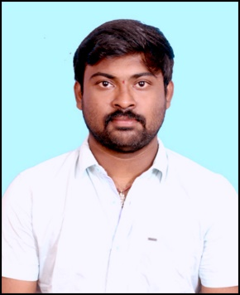

1

© Capgemini 2017. All rights reserved

|

Presentation Title | Author | Date



**Strengths**

**Achivement**

**Education and certificates**

**Base Location:**

**Email ID:**

**Mobile No:**

**Grade:**



**Online Home Decor Store Application**

Completed end to end case study of

Online Home Decor

Store Application

with the help of Spring boot and postgre SQL

Database .React framework used for user interface.

**Designed Static and Dynamic Web Pages**

Developed website with HTML5 and CSS3 Along with React

Framework to make website more interactive and colorful.

**Certifications**

Full Stack Java Development Certification from JS Spider

Spiders

JHTUH,Hyderabad

Analyst/Software Engineer

Mumbai

lakshmana-venkata-durga-sai-ganesh.thota@capgemini.com

+91

9573926967

•

A Self driven learner with Front

-

End and Back

-

End

knowledge. Passionate about implementing and

launching new projects.

•

Ready to learn new technologies/Frameworks and

implement them to further improve my knowledge.

•

A team player with good communication skill always

ready to work for the enrichment of knowledge.

•

Has working knowledge on React and Java

Microservice Development using Spring framework on

an beginner level.

•

Have decent knowledge on Databases like SQL,

My SQL and Postgres SQL.

Bachelor of Technology In

Electronics And Communication

: 2017

-

Engineering : 2016-2020

**Skills**

Spring Boot

Spring MVC

React Framework

Bootstrap

Node JS

**Backend**

Spring Boot

Spring MVC

REST

-

API

NodeJS

**Database**

MySQL

Postgre SQL

**Web Technologies**

HTML5

CSS3

JavaScript

**AddOns**

Github

Maven

Postman

**Additional Details**

Excellent Communication Skills

Team Player

**LVDS GANESH THOTA**



Check out my work on GitHub & Video Profile



A4